PERIODIC TEST - II (22 - 23)
NAME: ____________________
SUBJECT: English
GRADE: 3 ____
DATE: 18. 8. 22
TIME : 1 ½ Hours

I. Read the passage and answer the following. (5×1=5)

Spiders are found in almost all houses. There are many types of spiders. More than 40,000 species of spiders have been discovered. Spiders are carnivorous.The spiders found in the houses are not very big. The size of the spiders living in the forests is quite large.Spiders have eight legs and two body segments. They generally eat insects. Spiders get their food by making a web at their places.The delicious food of house spiders is the eggs of black ants. The spiders of jungles eat frogs and small birds with great fervor

Questions –

1. How many species of spiders have been discovered so far?

____________________________________________________________

2. What do the spiders of jungles eat?

____________________________________________________________

3. Are spiders carnivorous?

____________________________________________________________

4. What do spiders generally eat?

____________________________________________________________

5. What is the delicious food of house spiders?

____________________________________________________________

II. Picture description (1×3=3)

6. Write 5 sentences on the pictures given below.

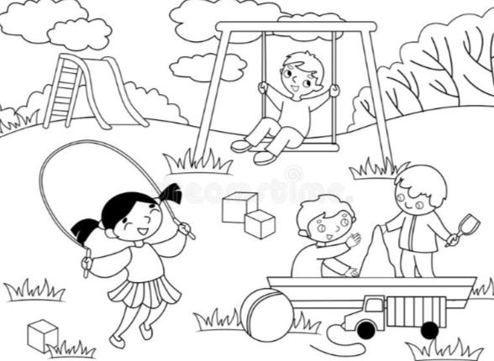

III. Write the synonym of the following. (5×1=5)

7. Wailing -

8. Astonishment -

9. Alert -

10. Nimbly -

11. Suspicious -

IV. Answer the following (3×2=6)

12. How did Misha solve the problem?

____________________________________________________________
____________________________________________________________
____________________________________________________________
____________________________________________________________
13. Who stole all the trinkets? Where was it found?

____________________________________________________________
____________________________________________________________
____________________________________________________________
____________________________________________________________

14. Misha's allergy (sneezing) helped her. How?

____________________________________________________________
____________________________________________________________
____________________________________________________________
____________________________________________________________

V. Answer the following. (1×4=4)

15. Name all the characters of the story ' Misha Solves a Mystery' and mention what they have lost in the story.

___________________________________________________________
____________________________________________________________
____________________________________________________________
____________________________________________________________
____________________________________________________________
____________________________________________________________
____________________________________________________________
____________________________________________________________
____________________________________________________________
____________________________________________________________

VI. Form the questions to answers. (3×1=3)

16. You may come in.
____________________________________________________________

17. You may borrow the pencil.
____________________________________________________________

18. You may leave now.
____________________________________________________________

VII. Complete the sentence using 'May' or 'Can' (2×1=2)
19. We _________ come tomorrow to meet you.
20. Misha __________ climb a tree nimbly.
VIII. Write 2 sentences using 'May' in a NEGATIVE form. (2×1=2)
21. _________________________________________________________
22. ________________________________________________________

IX. Write the plural form of the following words. (4×1/2=2)

23. Baby
24. Leaf
25. Holiday
26. Box

X. Frame a sentence using the plural form of : (6×1=6)
27. Mango - _______________________________________________
28. Knife - ________________________________________________
29. Wolf - ________________________________________________
30. Lady - ________________________________________________
31. Roof - ________________________________________________
32. Pens - ________________________________________________

XI. Draw and colour. (1×2=2)
33. A bouquet of flowers.

